The Holy Spirit

Through the Holy Spirit comes our restoration to Paradise, our ascension to the Kingdom of heaven, our adoption as God’s sons [children], our freedom to call God our Father, our becoming partakers of the grace of Christ, being called children of light, sharing in eternal glory, and in a word, our inheritance of the fullness of blessings, both in this world and the world to come.

Basil of Caesarea (AD 330-379), On the Holy Spirit

The Trinity

- The Holy Spirit is the third person of the Trinity (God the Father is the first person, and God the Son is the second person).
- The Trinity is not a math problem to be solved; the Trinity is who God is. God is, always has been, and always will be Father, Son, and Holy Spirit.
  - The Trinitarian understanding of God doesn’t come into focus in the Old Testament; however, as Christians we look back and see the Trinitarian God at work in the Old Testament (i.e., the God of Israel, who creates the world, sends the flood, calls Abraham, Isaac, and Jacob unto himself, delivers his people from bondage in Egypt, makes covenant with them in the desert, raises up kings and speaks through prophets, is the Trinitarian God).
  - While the word “Trinity” isn’t used in the New Testament, the Trinitarian understanding of God comes into focus in the New Testament.
    - Jesus’s baptism

¹⁶ After his baptism, as Jesus came up out of the water, the heavens were opened and he saw the Spirit of God descending like a dove and settling on him. ¹⁷ And a voice from heaven said, “This is my dearly loved Son, who brings me great joy.”

Matthew 3:16-17 (NLT)

    - Paul’s benediction at the end of 2 Corinthians

¹⁴ May the grace of the LORD JESUS CHRIST, the love of GOD, and the fellowship of the HOLY SPIRIT be with you all.

2 Corinthians 13:14 (NLT, emphasis added)

- The three persons of the Trinity are CO-EQUAL (none is greater or less than another) and CO-ETERNAL (none were created, and all three have aways existed).
- While the three persons enjoy unity and oneness, it is important to note that they’re distinct from each other.
The Trinity (continued)

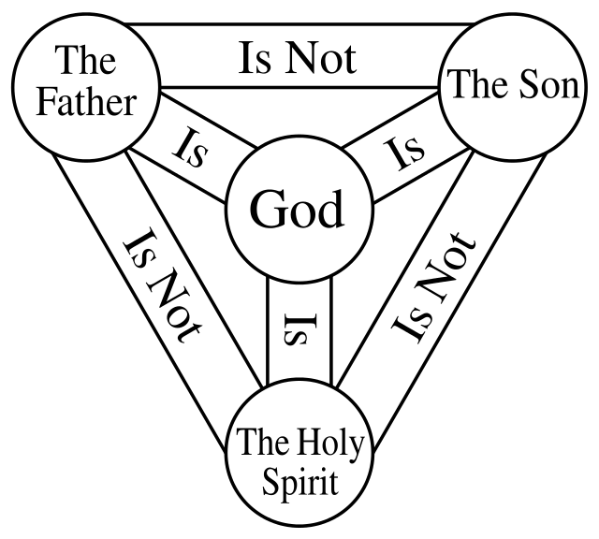

Shy Person

- In the Apostles’ Creed (the oldest statement of faith outside the Bible), the article about God the Father in has 12 words; the article about Jesus the Son has a whopping 65 words; the article about the Holy Spirit has six words, which is less than six percent of the whole creed.
  - Less than six percent of the creed is devoted to one of the persons of the Godhead – what gives?!
- The Holy Spirit is OK with receiving less attention than the other two persons of the Trinity, particularly Jesus, because the Holy Spirit wants to bring us into relationship with God through Jesus.

It’s often been said that the Holy Spirit is …the great neglected Person of the Godhead. But the Holy Spirit’s desire and work is that we be overcome again, thrilled again, excited and gripped again by the wonder, the majesty, the relevance of Jesus.

Fredrick Dale Bruner & William Hordern, The Holy Spirit: Shy Member of the Trinity (1984)

- The Holy Spirit is shy, but not in the sense of timidity; rather, the Spirit in the sense of DEFERENCE. The Holy Spirit defers and brings attention to Jesus.

²⁶ But when the Father sends the Advocate as my representative—that is, the Holy Spirit—he will teach you everything and will remind you of everything I have told you.

John 14:26 (NLT)

- Will Willimon has referred to the Holy Spirit as the Ed McMahon of the Trinity (“Heeeeere’s Jesus!”).
The Holy Spirit in the Old Testament

- In the Old Testament, the Hebrew word ruah is translated by three primary words: wind, breath, and spirit. Context determines the translation, but ruah is the normal word for Spirit in the Old Testament. This includes the Spirit of God.
- While God the Spirit is eternal, the Spirit moves more subtly in the Old Testament.
  - In the Creation story, the Spirit hovers over the primordial waters.

In the beginning God created the heavens and the earth. ² The earth was formless and empty, and darkness covered the deep waters. And the Spirit of God was hovering over the surface of the waters.

Genesis 1:1 (NLT)

  - God also breathes the Spirit when he creates the first man.

⁷ Then the Lord God formed the man from the dust of the ground. He breathed the breath of life into the man’s nostrils, and the man became a living person.

Genesis 2:7 (NLT)

  - The Spirit of the Lord stirs in Samson, who later becomes judge over Israel.

²⁴ When her son was born, she named him Samson. And the Lord blessed him as he grew up. ²⁵ And the Spirit of the Lord began to stir him while he lived in Mahaneh-dan, which is located between the towns of Zorah and Eshtaol.

Judges 13:24-25 (NLT)

  - God sends the Spirt upon David following his anointing as Israel’s king.

¹³ So as David stood there among his brothers, Samuel took the flask of olive oil he had brought and anointed David with the oil. And the Spirit of the Lord came powerfully upon David from that day on. Then Samuel returned to Ramah.

1 Samuel 16:13 (NLT)

  - The New Testament reminds us that the prophets of old spoke by the Spirit of God.

²⁰ Above all, you must realize that no prophecy in Scripture ever came from the prophet’s own understanding, ²¹ or from human initiative. No, those prophets were moved by the Holy Spirit, and they spoke from God.

2 Peter 1:20-21 (NLT)
In addition to the above, there are instances in which women receive the Holy Spirit’s presence and power.

- Miriam: Miriam was the sister of Moses and Aaron. In Numbers 12:2, we find that the Lord speaks to Moses, Aaron, and Miriam. Although the specific mention of the Holy Spirit is not present, Miriam is a prophet and leader among the Israelites.

²⁰ Then Miriam the prophet, Aaron’s sister, took a tambourine and led all the women as they played their tambourines and danced. ²¹ And Miriam sang this song:
“Sing to the Lord,
for he has triumphed gloriously;
he has hurled both horse and rider
into the sea.”
Exodus 15:20-21 (NLT)
- Deborah: Deborah is one of the prominent figures in the Book of Judges. She was a judge and a prophet who received messages and guidance from the Lord. Judges 4:4 states that “Deborah, wife of Lappidoth, was a prophet who judging Israel at that time” (NLT). Her leadership and prophetic role demonstrate a connection with the Holy Spirit’s inspiration.

- Huldah: Huldah was a prophet mentioned in 2 Kings 22:14-20 and 2 Chronicles 34:22-28. When the Book of the Law was discovered in the temple during King Josiah’s reign, Hilkiah the priest consulted Huldah for interpretation. Huldah’s response carries the authority of a prophet and implies the presence of the Holy Spirit’s guidance.

These are just a few examples of women in the Old Testament who receive the inspiration and guidance of the Holy Spirit. While the specific phrase “Holy Spirit” may not always be mentioned, their prophetic roles and the actions attributed to them indicate the influence of divine inspiration.

The Holy Spirit in the New Testament

- In the New Testament, the word for Spirit is the Greek word pneuma.
  - In Christian theology the study of the Spirt is referred to as pneumatology.
- The Holy Spirit is far more overt in the New Testament.
  - The Holy Spirit causes Mary to conceive Jesus.

³⁵ The angel [Gabriel] replied, “The Holy Spirit will come upon you, and the power of the Most High will overshadow you. So the baby to be born will be holy, and he will be called the Son of God.

Luke 1:35 (NLT)
The Holy Spirit in the New Testament (continued)

  - The Holy Spirit fills Elizabeth and inspires her to announce the lordship of Jesus (Elizabeth is the first person in the New Testament to announce Jesus’ lordship).

⁴¹ At the sound of Mary’s greeting, Elizabeth’s child [John the Baptist] leaped within her, and Elizabeth was filled with the Holy Spirit.
⁴² Elizabeth gave a glad cry and exclaimed to Mary, “God has blessed you above all women, and your child is blessed. ⁴³ Why am I so honored, that the mother of my Lord should visit me?

Luke 1:41-43 (NLT)

  - Jesus promises the Holy Spirit (whom he called the Advocate) to his followers.

¹⁶ And I will ask the Father, and he will give you another Advocate, who will never leave you. ¹⁷ He is the Holy Spirit, who leads into all truth. The world cannot receive him, because it isn’t looking for him and doesn’t recognize him. But you know him, because he lives with you now and later will be in you.

John 14:16-17 (NLT)

  - Jesus breathes the Holy Spirit upon the disciples.

¹⁹ That Sunday evening the disciples were meeting behind locked doors because they were afraid of the Jewish leaders. Suddenly, Jesus was standing there among them! “Peace be with you,” he said. ²⁰ As he spoke, he showed them the wounds in his hands and his side. They were filled with joy when they saw the Lord! ²¹ Again he said, “Peace be with you. As the Father has sent me, so I am sending you.” ²² Then he breathed on them and said, “Receive the Holy Spirit. ²³ If you forgive anyone’s sins, they are forgiven. If you do not forgive them, they are not forgiven.”

John 21:19-23 (NLT)

  - The Holy Spirit comes upon the whole church at Pentecost.

On the day of Pentecost all the believers were meeting together in one place. ² Suddenly, there was a sound from heaven like the roaring of a mighty windstorm, and it filled the house where they were sitting. ³ Then, what looked like flames or tongues of fire appeared and settled on each of them. ⁴ And everyone present was filled with the Holy Spirit and began speaking in other languages, as the Holy Spirit gave them this ability.

Acts 2:1-4 (NLT)
The Holy Spirit in the New Testament (continued)

    - Many have rightly pointed out that Pentecost marks the reversal of Babel (Genesis 11:1-9). At Babel, God confuses languages. However, at Pentecost, God brings people of all languages together and unites them.

The Holy Spirit in Our Lives

- Because the Holy Spirit (as we noted earlier) works to bring us to Jesus, the Spirit is present in our lives from the very start. As United Methodists, we understand this sort of divine activity as prevenient grace (the grace that precedes or comes before us).

⁶ Yes, you have been with me from birth;
from my mother’s womb you have cared for me.
No wonder I am always praising you!
Psalm 71:6 (NLT)

- The Holy Spirit convicts (i.e., convinces us) of sin (John 16:8).
  - We don’t convict the world of sin, the Holy Spirit does!
⁸ And when he [the Holy Spirit] comes, he will CONVICT the world of its sin,
John 16:8 (NLT, emphasis added)
- The Holy Spirit CAN BE resisted.
  - Calvinists believe in irresistible grace. United Methodists, on the other hand, believe (based on what we believe the Bible teaches) that we can resist God’s grace through the Spirit.

⁵¹ “You stubborn people! You are heathen at heart and deaf to the truth. Must you forever resist the Holy Spirit? That’s what your ancestors did, and so do you!
Acts 7:51 (NLT)
- The Holy Spirit is the agent of sanctification (the renewal of our broken nature into the image of Christ).
²² But the Holy Spirit produces this kind of fruit in our lives: love, joy, peace, patience, kindness, goodness, faithfulness, ²³ gentleness, and self-control. There is no law against these things!
Galatians 5:22-23 (NLT)
The Holy Spirit in Our Lives (continued)

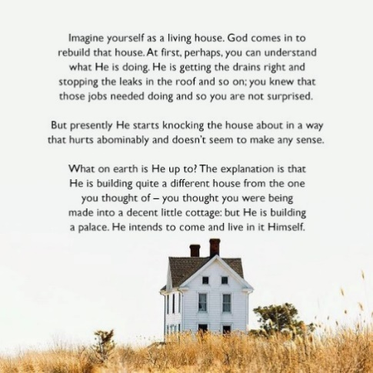
C.S. Lewis’ Mere Christianity (1952)

  - We partner with God, through the Spirit, in our sanctification through (what the Wesleys called) the means of grace.
    - The means of grace are ordinary channels through which God fills us with sanctifying grace (i.e., grace that empowers us for holy living).
Work hard to show the results of your salvation, obeying God with deep reverence and fear. ¹³ For God is working in you, giving you the desire and the power to do what pleases him.
Philippians 2:12b-13 (NLT)

    - The means of grace include two categories:
      - Works of Piety (e.g., attending worship, reading the Bible, receiving Holy Communion)
      - Works of Mercy (e.g., visiting the sick and imprisoned, working to change systems that hurt, marginalize, and victimize people)
The Holy Spirit in the Church

- The Holy Spirit is present in our individual lives, but the Spirit is also present in our collective lives. To put it another way, the Spirit is present through the church.
- Paul likens the church to a human body and contends that each of us is a member.

¹² The human body has many parts, but the many parts make up one whole body. So it is with the body of Christ.

1 Corinthians 12:12 (NLT)

⁴ Just as our bodies have many parts and each part has a special function, ⁵ so it is with Christ’s body. We are many parts of one body, and we all belong to each other.

Romans 12:4-5 (NLT)

- We use our Spirit-given gifts to contribute to the body, so the ministry of Jesus continues.

⁶ In his grace, God has given us different gifts for doing certain things well. So if God has given you the ability to prophesy, speak out with as much faith as God has given you. ⁷ If your gift is serving others, serve them well. If you are a teacher, teach well. ⁸ If your gift is to encourage others, be encouraging. If it is giving, give generously. If God has given you leadership ability, take the responsibility seriously. And if you have a gift for showing kindness to others, do it gladly.
Romans 12:6-8 (NLT)

⁴ There are different kinds of spiritual gifts, but the same Spirit is the source of them all. ⁵ There are different kinds of service, but we serve the same Lord. ⁶ God works in different ways, but it is the same God who does the work in all of us.
⁷ A spiritual gift is given to each of us so we can help each other. ⁸ To one person the Spirit gives the ability to give wise advice; to another the same Spirit gives a message of special knowledge. ⁹ The same Spirit gives great faith to another, and to someone else the one Spirit gives the gift of healing. ¹⁰ He gives one person the power to perform miracles, and another the ability to prophesy. He gives someone else the ability to discern whether a message is from the Spirit of God or from another spirit. Still another person is given the ability to speak in unknown languages, while another is given the ability to interpret what is being said. ¹¹ It is the one and only Spirit who distributes all these gifts. He alone decides which gift each person should have.
1 Corinthians 12:7-11 (NLT)
The Holy Spirit in the Church (continued)

¹⁰ God has given each of you a gift from his great variety of spiritual gifts. Use them well to serve one another. ¹¹ Do you have the gift of speaking? Then speak as though God himself were speaking through you. Do you have the gift of helping others? Do it with all the strength and energy that God supplies. Then everything you do will bring glory to God through Jesus Christ. All glory and power to him forever and ever! Amen.
1 Peter 4:10-11 (NLT)

- In the above passages, Paul and Peter reference spiritual gifts rather than natural abilities.
  - We sometimes confuse natural abilities and spiritual gifts.
    - Both natural abilities and spiritual gifts come from God; however, they are categorically different.
      - Natural abilities are the things that we naturally do well (e.g., playing a musical instrument, singing, working with tools, or fixing things up). Spiritual gifts, on the other hand, are supernatural abilities that the Holy Spirit gives us.
        - Natural abilities are given at birth; spiritual gifts are given at our rebirth.
      - The Spirit calls and invites us to use our natural abilities and spiritual gifts in service to the church so the whole might be built up.

Greater works than Jesus?!

- Jesus left us with an incredible promise.

¹² “I tell you the truth, anyone who believes in me will do the same works I have done, and even greater works, because I am going to be with the Father.

John 14:12 (NLT)

  - Jesus likely meant that when he was among us, because he was in a body like ours, he could only be in one place at one time. However, upon his return to heaven, the Spirt would come upon all Jesus’ followers, allowing them to join together (with their natural abilities, spiritual gifts, and resources) and bring ministry to the whole world in his name.

If you would like to find out your spiritual gifts, go to the following webpage and complete the assessment: umcdiscipleship.org/spiritual-gifts-inventory/en. If you don’t have access to a computer, stop by the church office so we can print out an assessment for you.

