The Asbury Now And Forever Fund

The Lord’s Prayer teaches us that God’s Kingdom is among us here and now. But it also promises that God’s power and glory will reign forever and ever. And 2 Peter 3:18 advises us to “… grow in the grace and knowledge of our Lord and Savior Jesus Christ. To Him be the glory both now and forever.”

Our new endowment fund will help ensure our church continues to help people know the love of Jesus Christ and to pass it on both today and tomorrow.

What Is An Endowment Fund?

An endowment fund is made up of money or other financial assets that are donated to a charity – in our case, to Asbury United Methodist Church. The principal is invested, and the resulting income may be used for further investments and supplementary expenditures. The Now and Forever Fund does not replace Asbury’s annual stewardship and budgeting process. Rather, it supplements annual giving and through investments can provide support well beyond the annual budget.
What Are The Benefits Of
An Endowment Fund?

Most often when we think of making gifts to our church, we naturally think of giving from our income. However, gifts to the Now and Forever Fund can offer benefits to both the giver and the church.

For givers, the fund provides:
  - A means to leave a legacy in the ongoing work of the church.
  - A vehicle to include Asbury in financial, tax and estate planning.
  - A way gifts can continue to give beyond the giver’s lifetime.
  - A means to gift non-monetary assets.

For Asbury, the fund will:
  - Help ensure long-term financial security through the fund’s income stream.
  - Provide funds for church ministries and needs apart from the general budget giving.
  - Supplement budget contributions to strengthen and expand Asbury’s current ministries and programs.
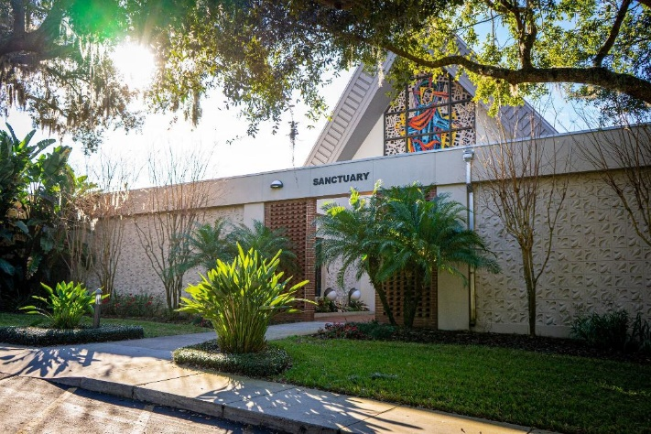
  - Increase gifts to fund various ministries.
It’s Easy To Give To
The Now And Forever Fund

Your gift may be made in a variety of ways. Thanks to The Now and Forever Fund, you can make charitable contributions to Asbury in just the same way you might donate to any other charity. These may take the form of:

Outright Gifts
  - Cash
  - Life Income Arrangements such as Charitable Gift Annuities and Charitable Trusts
  - Life Insurance
  - Appreciated Securities
  - Real Estate
  - Retirement Plans
  - Art collections, antiques and collectables

Planned Gifts
  - Wills and Bequests
  - Life Estates
  - Life Insurance Policies
  - Life Income Programs
  - Retirement Plan Gifts

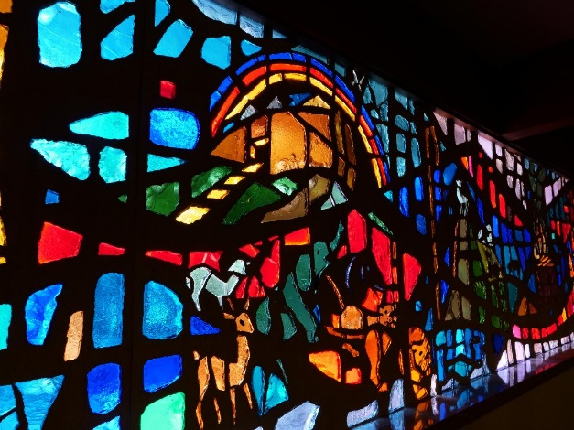
Do not withhold good from those
who deserve it
when it’s in your power
to help them.
- Proverbs 3:27

John replied, “If you have two shirts,
give one to the poor.
If you have food,
share it with those who are hungry.”
- Luke 3:11

Whatever you give is acceptable
if you give it eagerly.
And give according to what you have,
not what you don’t have.
- 2 Corinthians 8:12

No one should appear before the LORD empty-handed.
Each of you must bring a gift in proportion
to the way the LORD your God
has blessed you.
- Deuteronomy 16:16-17
Supported by
The Florida United Methodist Foundation

We launched The Now And Forever Fund with the expertise and assistance of the Florida United Methodist Foundation (FUMF), which works with churches throughout Florida to establish endowment programs and promote planned giving. We will continue to work with the FUMF, utilizing their wealth of experience, resources, and skilled advisors.

Flexibility to Fit Your Personal Situation

We would be pleased to discuss your interest in or desire to explore a planned giving approach that reflects your personal situation. If you would like additional information, or would like to discuss contributing to the fund, please contact: Pastor Chris Jones, Pastor Will Kendust, Larry Koch, Dave Nadler, or contact the office and we’ll arrange a call-back.

Disclaimer and Contact Information

The purpose of this publication is to provide general gift giving information. Neither the author nor this organization is engaged in rendering legal or tax advisory service. State laws will govern wills, trusts and charitable gifts made in a contractual agreement. For advice and assistance in specific cases, the services of an attorney or other professional advisor should be obtained.

Asbury United Methodist Church
220 W. Horatio Avenue, Maitland, FL 32751
407.644.5222
www.asburymaitland.org
receptionist@asburymaitland.org

The Asbury Now
And Forever Fund

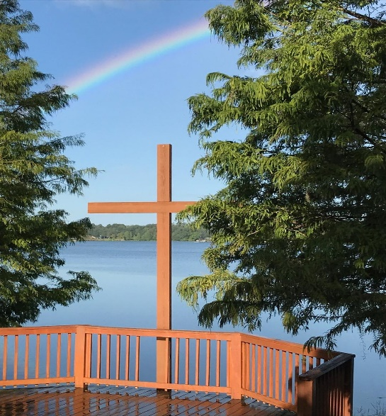
Your lasting legacy will be
The lives that will be touched
By the ministries of
Asbury United Methodist Church

