Christmas in the Four Gospels
2021 Advent Study
What is a Gospel?
Gospel is a genre of literature that we associate with the opening books of the New Testament: Matthew, Mark, Luke, and John.
Gospel comes from the Greek word euangelion, which means “good news.” (It’s also where we get the English word “evangelist.”) The Gospels present us with the “good news” of Jesus.
This is the Good News [euangelion] about Jesus the Messiah, the Son of God. Mark 1:1 (NLT)
While the Gospels contain biographical elements, they’re not biographies in the modern sense of the term. That’s because they don’t give us a full account of the life of Jesus.
The Gospels are more interested in making sure that we, as the readers, know the necessary stuff about Jesus – that he was crucified, dead, and buried, and that he rose again from the dead.
Recap of Christmas in Mark
Mark, the shortest of all the Gospels, doesn’t include a birth narrative. If Mark were our only Gospel, we would have no knowledge of the events surrounding the birth of Jesus. Why doesn’t Mark include a birth narrative? Two possible reasons.
- He doesn’t know a birth narrative.
- A birth narrative isn’t necessary to Mark’s theological agenda.
  - Mark’s main concern is making sure we understand that Jesus is the suffering Son of God. Mark writing style is terse and to the point. His entire narrative pushes toward – and culminates at – the cross.
Recap of Christmas in Matthew
Matthew was likely the second Gospel composed – written shortly after the Gospel of Mark. Matthew writes as a Jewish Christian whose chief intent is to show that Jesus is a fulfillment of all the promises God made to Israel. To put it simply, Matthew situates Jesus firmly in the story of Israel.
- Matthew’s genealogy begins with Abraham and David, two pivotal figures for Judaism.
- Matthew makes heavy use of Moses typology throughout his Gospel, showing that Jesus is a new and greater Moses. (Moses is the main figure of the Hebrew Scriptures.)
- The story of the Magi (Wise Men) reminds us of Jesus’ royal status, which is fitting for a descendant of King David.
- The story of the flight into Egypt shows how God called Jesus out of Egypt just like God called Israel out of Egypt (where Israel was enslaved).
  - In this sense, Jesus embodies the story of Israel.
Christmas in Luke
The Gospel of Luke
- Written sometime between 80-90AD.
- An anonymous document (like all the Gospels). However, Church tradition claims that Luke wrote it.
  - The Muratorian Fragment, also known as the Muratorian Canon or Canon Muratori, is a copy of perhaps the oldest known list of most of the books of the New Testament. Composed as early as 170AD, the Muratorian Fragment identifies Luke (the travelling companion of Paul) as the author of this Gospel.

¹⁴ Luke, the beloved doctor, sends his greetings, and so does Demas.
Colossians 4:14 (NLT)

  - Paul is the one who gives this Gospel “apostolic authority”
    - All the canonical gospels are associated with an apostle.
  - The same person who wrote Luke also wrote the Book of Acts.

³ Having carefully investigated everything from the beginning, I also have decided to write an accurate account for you, most honorable Theophilus, ⁴ so you can be certain of the truth of everything you were taught.
Luke 1:3-4 (NLT emphasis added)
¹ In my first book I told you, Theophilus, about everything Jesus began to do and teach ² until the day he was taken up to heaven after giving his chosen apostles further instructions through the Holy Spirit.
Acts 1:1-2 (NLT emphasis added)
- Theophilus simply means “friend of God.” (Theos is the Greek word for God, while “philus” is derived from the Greek word “philos,” which refers to friend-like love or sibling-like love.
  - Philos is where we get the word “Philadelphia.”

- Luke is the only Gentile writer in Scripture of whom we know. His intent is to show that Jesus is the universal Son of God who has come not only for the Jews, but for the Gentiles, too.
  - Luke’s genealogy for Jesus goes all the way back to Adam, who is the universal father for ALL human beings – Jews and Gentiles alike (Luke 3:23-38).
- Luke’s desire is to present an “orderly account” of the events of Jesus’ life, ministry, death, and resurrection (Luke 1:1-3). He writes as a historian.

- Special attention is given in Luke to the outcast and marginalized (e.g., shepherds, the poor, women, children, tax collectors, the sick and demon-possessed, and convicted criminals).
The Birth of John the Baptist Foretold (Luke 1:5-25)

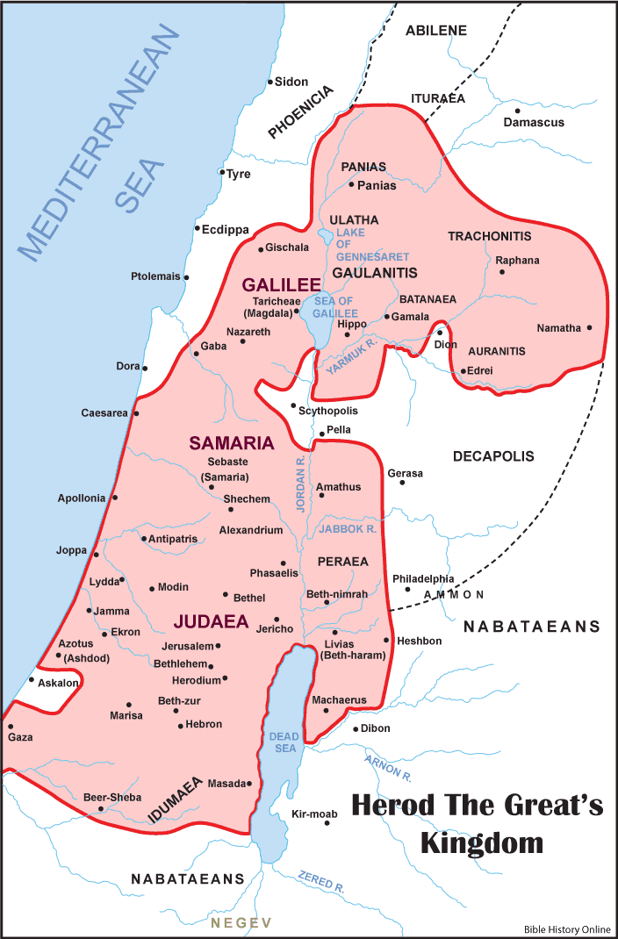

John’s birth happens during the reign of Herod the Great, who ruled over the Roman province of Judea (Luke 1:5).

- Luke names historical persons to situate John’s (and Jesus’ birth) in a particular period of history.

Luke is quick to point out that Elizabeth and Zechariah were “righteous in God’s eyes, careful to obey all the Lord’s commandments and regulations” (Luke 1:6).

- Social and spiritual stigma associated with failure to produce offspring (Luke 1:25).
- After discovering that she is pregnant, Elizabeth remains in seclusion for five months (1:24).
  - Possibly because she had suffered miscarriages in the past and feared yet another miscarriage.
Zechariah and Elizabeth are promised a child who will come “with the spirit and power of Elijah” (Luke 1:17).
- Elijah is Israel’s most famous prophet.
  - Just like Moses represents the law, Elijah represents the prophets.

The Birth of Jesus Foretold (Luke 1:26-38)

Nazareth
- Population of 100-400 at the time of Mary.
- Most of the people were working-class and lived in caves made out of limestone.
- Situated about four or five miles from the larger city of Sepphoris.

The significance of God’s decision to choose Nazareth

- Demonstrates God’s use of the “least of these” to accomplish his purposes.
  - God chose the Israelites, a nation of nobodies, to be his people.
  - God used Moses, who didn’t possess appropriate communication skills, to speak to Pharaoh.
  - God chose David, Jesse’s youngest son, to be King over Israel.

Comparing and Contrasting Mary and Zechariah

Differences:
- Zechariah was older; Mary was younger.
- Zechariah was male; Mary was female.
- Zechariah was educated; Mary was uneducated.

Similarities:

- Both were followers of God.
- Both were met by the angel Gabriel (Luke 1:19, 26).
- Both were promised unusual pregnancies.
  - Elizabeth’s pregnancy was unusual because she was older (Luke 1:19).
  - Mary’s pregnancy was unusual because she was a virgin (Luke 1:26).
- Both responded to Gabriel’s message with confusion.

¹⁸ Zechariah said to the angel, “How can I be sure this will happen? I’m an old man now, and my wife is also well along in years.”
Luke 1:18
³⁴ Mary asked the angel, “But how can this happen? I am a virgin.”
Luke 1:34 (NLT)
Why was Zechariah punished for questioning Gabriel’s message while Mary was not?

- Perhaps Gabriel held Zechariah to a higher standard because of his education and credentials.
- Perhaps Gabriel was more understanding of Mary due to her age and maturity level.
- Perhaps the difference lies within the tone of the response.
- Perhaps Mary wasn’t punished because she believed the angel’s message (Luke 1:45). However, Zechariah did not (Luke 1: 20).
- Other explanations?
Mary’s visit with Elizabeth (Luke 1:39-56)
Shortly after Gabriel’s visit, Mary hurries off to see Elizabeth, who lived with her husband in the “hill country of Judea” (Luke 1:39). This place has traditionally been identified as Ein Karem.

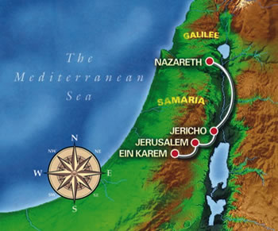
Why did Mary go to see Elizabeth?
- Desire to get out town.
- Looking for confirmation.
- Hoping for understanding.
- Proximity to Bethlehem, where Joseph lived.
  - This might have been when Mary revealed the news to Joseph (Matthew 1:18-25).
Mary’s Relationship to Elizabeth
- Kinswoman/relative (Luke 1:36).
- Mentor/Mentee.
Elizabeth’s Inspired Speech (Luke 1: 41b-45)
- Inspired by the Holy Spirit (Luke 1:41b).
- First proclamation in the Gospels of Jesus’ lordship (Luke 1:43).
- John the Baptist bears witness to the identity of Jesus as the long-awaited Messiah in utero (Luke 1:44).
- Threefold use of the word “blessed” (Luke 1:42, 45).
  - The paradox of blessedness.
Mary’s Song (Luke 1:46-55)
- Often called the Magnificat (which comes from the Latin for “My soul magnifies”, the first words of the song).
- Saturated with the Old Testament (1 Samuel 2:1-10).
- Shows Mary’s deep devotion to God and knowledge of the Hebrew Scriptures.
- Implies Mary’s awareness of her exalted role (Luke 1:46-50).
- Strikes a revolutionary note (Luke 1:51-55).
- Demonstrates Luke’s portrait of Jesus as being concerned for the poor.
  - Sermon on the Mount (Luke 6:20-26).
  - Parable of the rich man and Lazarus (Luke 16:19-31).

⁵⁶ Mary stayed with Elizabeth about three months and then went back to her own home.
Luke 1:56 (NLT)

Mary’s visit with Elizabeth probably ended after the birth of John the Baptist.

The Birth of John the Baptist (Luke 1:57-66)
Zechariah’s Song (Luke 1:6-80)
The Birth of Jesus (2:1-7)
What did Mary and Joseph do once they (as an engaged couple) returned to Nazareth? How did they spend the next six months before going back to Bethlehem for the census?

A hastily planned wedding?
Adam Hamilton, United Methodist pastor and author of The Journey: Walking the Road to Bethlehem, suggests that Mary and Joseph had a “hurry up” wedding.

  - Neighbors would have wondered if pregnancy was the reason.
  - In those days, it wasn’t unheard of for an engaged couple to be found pregnant. Pregnancy during an engagement would not have been considered as scandalous as pregnancy outside of an engagement.
Problem with Hamilton’s suggestion:

It seems to overlook Luke 2:5 in which the Gospel writer clearly states that Mary and Joseph were still engaged at this point.

⁵ He took with him Mary, to whom he was engaged, who was now expecting a child.
Luke 2:5 (NLT emphasis added)

Another possibility of what Mary and Joseph did:
- The two returned to Nazareth as an engaged couple. Mary told her family she was pregnant. Afterwards, Mary and Joseph stayed low and arranged for the arrival of the baby, including the securing of a midwife.

The Census

In the first century AD, Israel was an occupied territory of the Roman government.

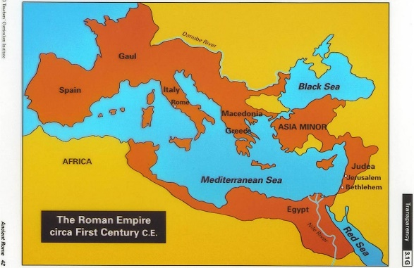

Since Joseph and Mary were engaged (Luke 2:5), in the eyes of the law, the two of them were married. Thus, even though she was pregnant, she had to travel with him.

The purpose of the census was to generate additional revenue through taxation.
Which route to Bethlehem?
There are two possible routes that Joseph and Mary took when travelling to Bethlehem.
Route #1: The first route would have taken Joseph and Mary east, crossing the Jordan, then south sixty miles, and finally re-crossing the Jordan near Jericho and west to Bethlehem.
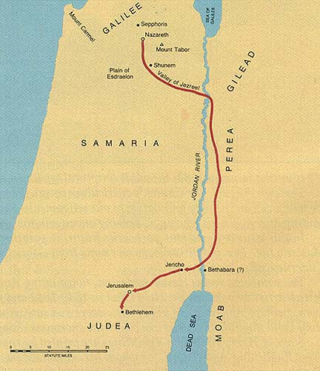

- This route would have been followed by Jews wishing to avoid the land of the Samaritans, a people of mixed descent whose faith was largely influenced by Judaism, but who were not considered “pure” Jews.
- Upside to this option: the Jordan River valley is plain and thus easier to traverse on.
- Downside to this option: it would have added an extra two days to the journey.
Route #2: The second – more direct – route took Joseph and Mary nearly due south from Nazareth through the Jezreel Valley and along the road near the Way of the Patriarchs.
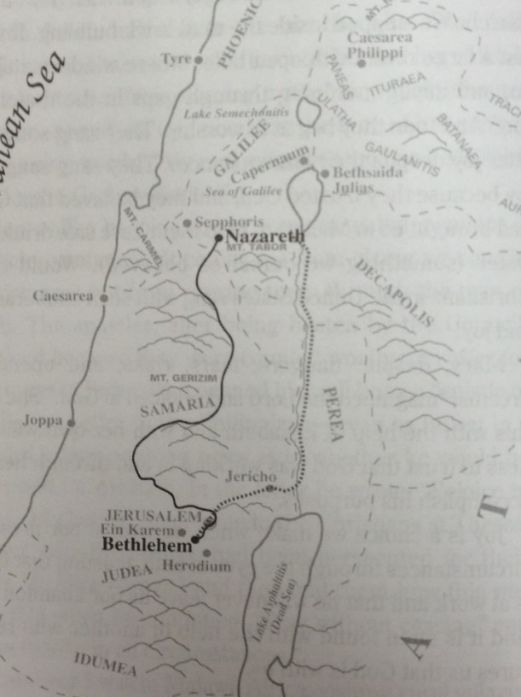
- First-century Jewish historian, Josephus, notes that during the Passover, when large numbers of Jews journeyed to Jerusalem, it was not uncommon for these Jews to go through Samaria.
- Upside to this option: it meant two fewer days of travel.
- Downside to this option: it was easier through the first half of the journey, but the second half included some hills and mountains.
Consider this: If Joseph and Mary did, in fact, follow this second route – the Way of the Patriarchs – they would have geographically traced 1600 years of biblical history.
They would have passed the places where
- God appeared to Abram (who later became Abraham) and promised to make him into a great nation.
- Jacob dreamt about a ladder with angels ascending and descending.
- Joseph, Jacob’s son, was buried after his bones were brought back from Egypt.

Thus the journey that I believe Mary and Joseph took to Bethlehem would have been both a recounting, geographically, of what scholars refer to as “God’s salvation history” and at the same time, because of the child in Mary’s womb, the apex of this history.
Adam Hamilton, The Journey: Walking the Road to Bethlehem, 92.

No room at the inn?

The Greek word traditionally translated here as “inn” is kataluma.
- This word can also be translated “spare room.” It appears one other time in the Gospels –
when Jesus sends his disciples ahead to find a room for the Last Supper.

¹⁰ He replied, “As soon as you enter Jerusalem, a man carrying a pitcher of water will meet you. Follow him. At the house he enters, ¹¹ say to the owner, ‘The Teacher asks: Where is the guest room where I can eat the Passover meal with my disciples?’
Luke 22:10-11 (NLT emphasis added)

- In the Parable of the Good Samaritan, Luke uses the Greek word pandokhein for “inn.”

³⁴ Then he [the Samaritan] put the man on his own donkey and took him to an inn, where he took care of him.
Lue 10:34 (NLT emphasis added)

- In Luke 2:7, the Gospel writer is likely referring to the spare bedroom in the house that belonged to Joseph’s family. Had Mary given birth in that room, the entire room (and all who were inside of it) would have been rendered unclean. (See Leviticus 15:19-23.)
Angels, Shepherds, and A Nighttime Birth (Luke 2: 8-20)
⁸ That night there were shepherds staying in the fields nearby, guarding their flocks of sheep.
Luke 2:8 (NLT).
Jesus was born at night just like he was resurrected “while it was still dark” (John 20:1). Of what significance is this?
Dear Jesus,
It’s a good thing you were born at night. This world sure seems dark. I have a good eye for silver linings. But they seem dimmer lately. These killings, Lord. These children, Lord. Innocence violated. Raw evil demonstrated. The whole world seems on edge. Trigger-happy. Ticked off. We hear threats of chemical weapons and nuclear bombs. Are we one button-push away from annihilation? Your world seems a bit darker this Christmas. But you were born in the dark, right? You came at night. The shepherds were nightshift workers. The Wise Men followed a star. Your first cries were heard in the shadows. To see your face, Mary and Joseph needed a candle flame. It was dark. Dark with Herod’s jealousy. Dark with Roman oppression. Dark with poverty. Dark with violence. Herod went on a rampage, killing babies. Joseph took you and your mom into Egypt. You were an immigrant before you were a Nazarene. Oh, Lord Jesus, you entered the dark world of your day. Won’t you enter ours? We are weary of bloodshed. We, like the wise men, are looking for a star. We, like the shepherds, are kneeling at a manger. This Christmas, we ask you, heal us, help us, be born anew in us.
Hopefully,
Your Children
(Max Lucado’s prayer following the shooting at Sandy Hook Elementary School in December of 2012.)
The significance of the shepherds.
- Lowliest of the low, and yet they technically became the first evangelists (Luke 1:17-18).

Which Lord are we talking about?

⁹ Suddenly, an angel of the Lord appeared among them, and the radiance of the Lord’s glory surrounded them. They were terrified, ¹⁰ but the angel reassured them. “Don’t be afraid!” he said. “I bring you good news that will bring great joy to all people. ¹¹ The Savior—yes, the Messiah, the Lord—has been born today in Bethlehem, the city of David!
Luke 2:9-11 (NLT)

In the first century AD, there was already “supposedly” a divine Son of God and Lord – Augustus Caesar.

Caesar Augustus came to power in 31 BC. Eventually, the story spread that Augustus really was the son of a god, that he was conceived during a union of Apollos and his human mother, Atia. Not surprisingly, Caesar’s birthday became a holy day. When it was observed, the birth of Augustus was declared a gospel: good news of our salvation. In fact, wherever Caesar’s empire stretched, when Rome conquered a new territory, military messengers (who were called “angels” in Greek) were sent out into the territory with a gospel. They would go to each of the towns and proclaim something to the effect of: “You, new subjects of Rome! Do not be afraid! I have a message of good news: Caesar has taken over the territory, bringing the peace and prosperity of Rome. You no longer need to worry about barbarians on your travel routes, foreigners invading your land, or a depressed economy—the Roman Empire will take care of all your needs. Caesar is Lord and Savior!”
This history sets the contextual backdrop for Jesus’ birth:
Jesus is being introduced as a rival king to Caesar, a rival Lord!

Luke makes clear that Jesus is good news for “all the people” (Luke 2:11). Again, Luke’s intent is to show that Jesus is the Savior of ALL human beings.

The significance of the manger

- Mentioned 3 times in Luke 2 (vv. 7, 12, 16).
- A feeding trough for animals.
  - In John’s Gospel, Jesus refers to himself as the “bread of life.”

³⁵ Jesus replied, “I am the bread of life. Whoever comes to me will never be hungry again. Whoever believes in me will never be thirsty.
John 6:35 (NLT)

For more information, visit Timothy McNinch’s blog post: https://timothymcninch.wordpress.com/2014/12/16/good-news-of-great-joy-for-all-the-people/.

